Lesson Submission by: Julia Minaker

|  |
| --- |
| **Lesson Title**: Who’s Within Secwepemcúl'ecw (lesson 1 of 3)  **Subject**: Social Studies  **Possible cross-curricular connections:**  **Grade range**: 3-4 |

|  |
| --- |
| **Rationale** - *This lesson will encourage students to ask more questions and think critically about the land they currently live on, where it came from, and who lived here before them.* |

|  |
| --- |
| **Prerequisite Concept and Skills** –  Students should understand who we are talking about when we say “Indigenous Peoples”  Students should understand what “First Peoples” mean  GR 2 SOCI- Diverse characteristics of communities and cultures in Canada and around the world, including at least one Canadian First Peoples community and culture  Students will demonstrate respect for differences |

|  |
| --- |
| **First Peoples Principles of Learning/Indigenous Content** - Learning is holistic, reflexive, reflective, experiential, and relational (focused on connectedness, on reciprocal relationships, and a sense of place).  This principle stood out to me as it really captures the ‘why’ of this lesson. Learning in this lesson promotes the students not only connecting with the land, but the people who live on it, and have lived on it for thousands of years. It explores the extent of the land they call Kamloops and demonstrates the variety of bands on this land. This lesson also fosters the space to observe in depth and meaningful teachings as to why acknowledgments are so important. |

|  |
| --- |
| **Materials and Resources** Pre-cut logos, labels, and maps (X number of groups)  Smartboard (can use projector)  Images for land acknowledgment (personal)  <https://curriculum.gov.bc.ca>  <http://www.fnesc.ca/first-peoples-principles-of-learning/>  <https://www.firstvoices.com> |

|  |
| --- |
| **Anticipated lesson time (30-90min?)**: 35-45 min |

**Lesson activities**:

|  |
| --- |
| In this lesson, student will discover bands from the territory they live on. They will engage in a hands-on sorting activity to establish different bands who originally, and still do, live on the land they are living and learning on. |

|  |
| --- |
| **Learning Intentions**:  I can understand why we do land acknowledgments.  I can understand who’s land I am on. |

|  |  |
| --- | --- |
| **Teacher activity** - Teacher will do in an in-depth land acknowledgment and lead a discussion around why we do land acknowledgments. Discuss why we are actively working towards reconciliation, and why it is important to make our land acknowledgments holistic, meaningful, and ensuring they have purpose.  Teacher Tips From <https://nativegov.org/news/a-guide-to-indigenous-land-acknowledgment/> : Why Land Acknowledgments “It is important to understand the longstanding history that has brought you to reside on the land, and to seek to understand your place within that history. Land acknowledgements do not exist in a past tense, or historical context: colonialism is a current ongoing process, and we need to build our mindfulness of our present participation.”  **Start with self-reflection.** Before starting work on your land acknowledgment statement, reflect on the process:   * Why am I doing this land acknowledgment? (If you’re hoping to inspire others to take action to support Indigenous communities, you’re on the right track. If you’re delivering a land acknowledgment out of guilt or because everyone else is doing it, more self-reflection is in order.) * What is my end goal? (What do you hope listeners will do after hearing the acknowledgment?) * When will I have the largest impact? (Think about your timing and audience, specifically.)   **Do your homework.** Put in the time necessary to research the following topics:   * The Indigenous people to whom the land belongs. * The history of the land and any related treaties. * Names of living Indigenous people from these communities. If you’re presenting on behalf of your work in a certain field, highlight Indigenous people who currently work in that field. Indigenous place names and language. * Correct pronunciation for the names of the Tribes, places, and individuals that you’re including.   **Use appropriate language.** Don’t sugar-coat the past. Use terms like genocide, ethnic cleansing, stolen land, and forced removal to reflect actions taken by colonizers. (age-appropriate terms) | **Student activity** - Student will respectfully engage and listen to discussion |
| Body:  Teacher will lead a discussion about local Indigenous communities. (These can vary per community- all communities not listed for time’s sake) Focusing on Adams Lake Indian Band, Little Shuswap Lake Band, Shuswap Indian Band, Simpcw First Nation, Skeetchestn, Splatsin, and Tk’emlups te Secwepemc.  Play names on First Voices to hear pronunciation.  <https://www.firstvoices.com>  Teacher will split students into groups and hand out matching supplies to each group. (Image 1- logos and words need to be printed and cut out separate)  Teacher will put blank map on projector and ask all students to stick their groups “guess” on the map, then reveal the actual location and logo (Image 2) | Students will listen to discussion  Student will practice repeating names on first voices.  Students will engage in a matching activity in groups of 4 or 5, first matching the names of the bands to the logos, then later they will match completed logo to a spot on a map. (Image 1 and 2 below) |
| Closure:  Teacher will wrap up by stating even though a lot of their guesses were incorrect (or correct), all guesses are on the Secwepemc land, as each band belongs within Secwepemcúl'ecw.  Teacher will explain that this is why we do land acknowledgments on the land we are on; it belongs to these bands.  Teacher will reiterate we do not just do land acknowledgments to get them out of the way, we do them because we are advocating for land back, and reconciliation. | Students will listen and ask questions.  Students will answer prompting questions like “why do you think we did this activity”  “Why are land acknowledgments important” |

|  |
| --- |
| **Assessment**: Students will be able to demonstrate full engagement in sorting activity. A large aspect of acknowledging land is respect, so students are expected to demonstrate this trough participation. |

|  |
| --- |
| **Extension** – (this lesson contains 2 more lessons as an extension) This lesson can also be extended by listing all communities on this land. Certain communities were selected for time and resource accessibility. |

Image 1:

Image 2:

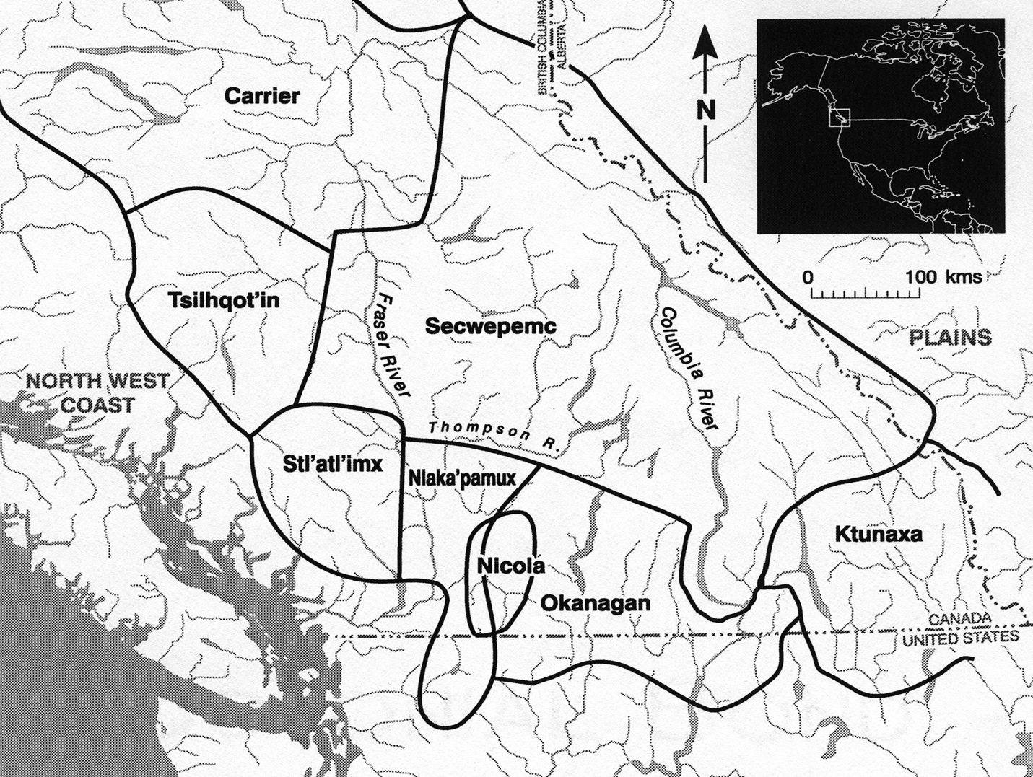

Map Answer Key:

